**9.Illustrate the concept of inter-process communication using shared memory with a C program.**

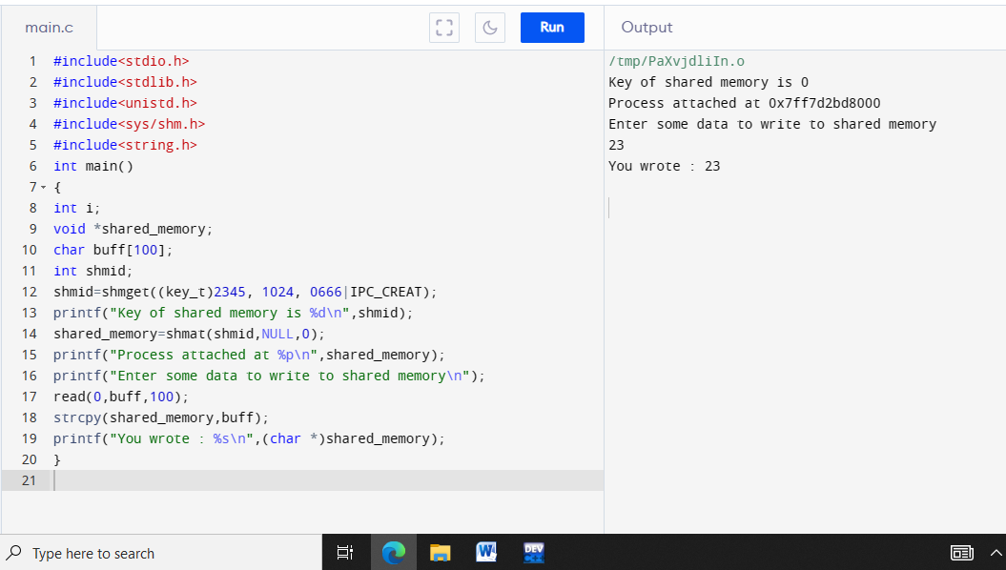

**10. Illustrate the concept of inter-process communication using message queue with a C program.**

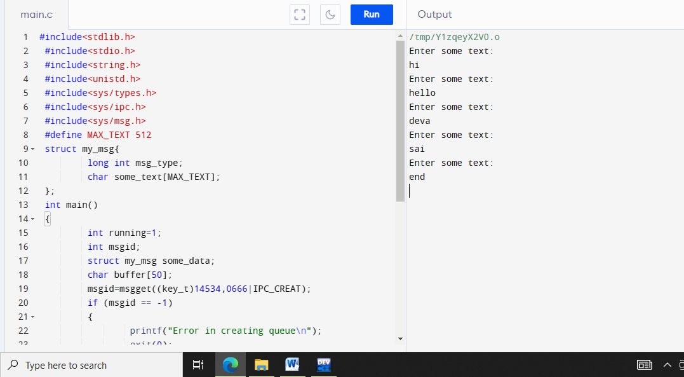

**11. Illustrate the concept of multithreading using a C program.**

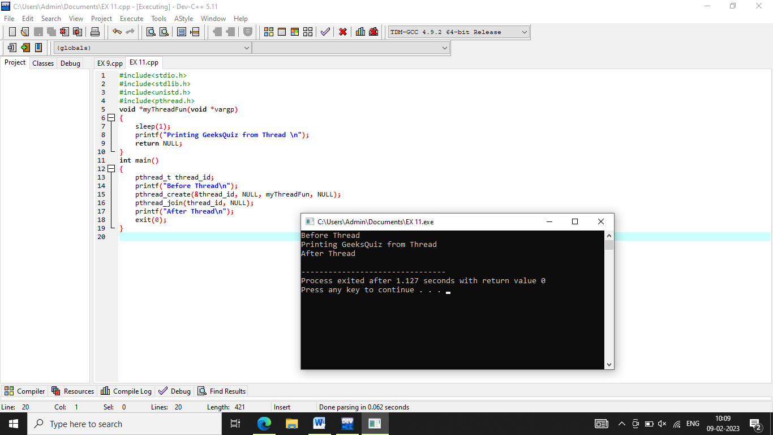

**12. Design a C program to simulate the concept of Dining-Philosophers problem.**

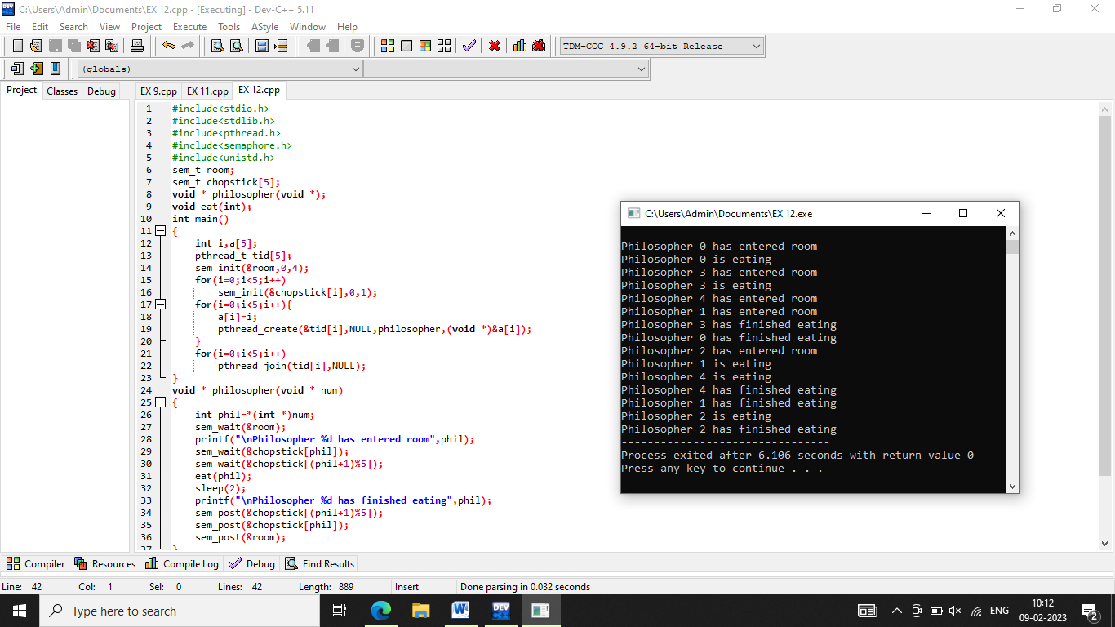

**13. Construct a C program for implementation the various memory allocation strategies.**

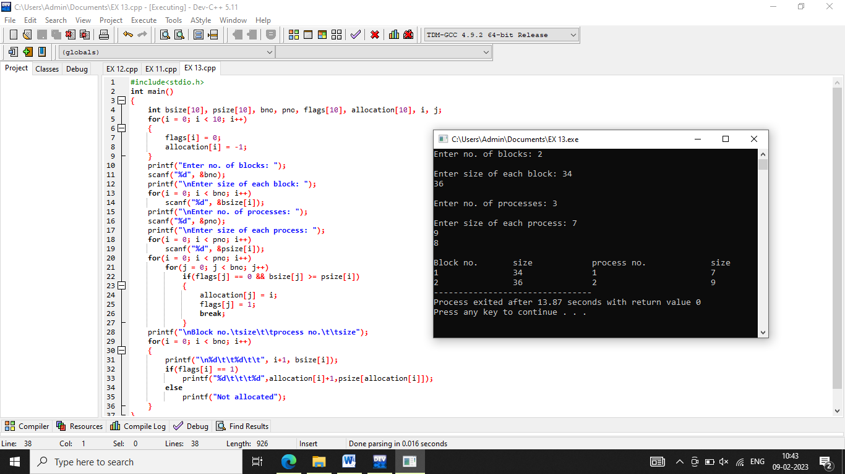

**14. Construct a C program to organize the file using single level directory.**

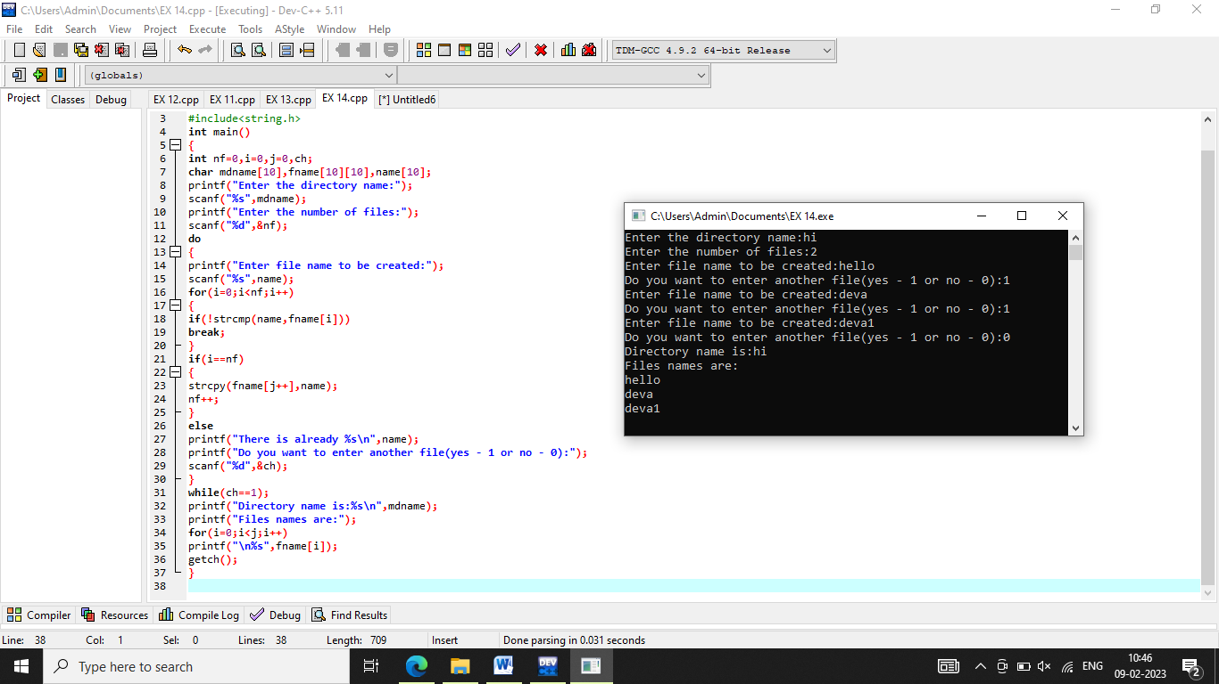

**15. Design a C program to organize the file using two level directory structure.**

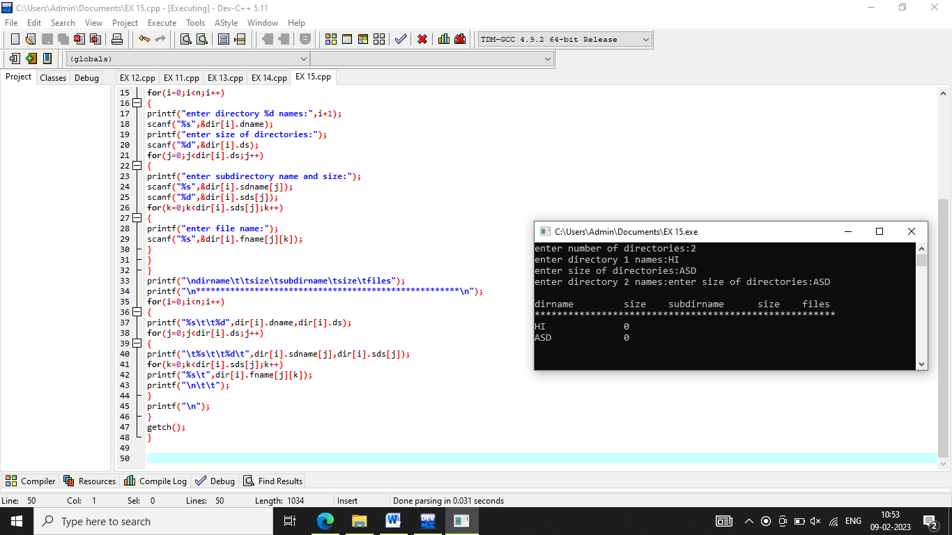

**16. Develop a C program for implementing random access file for processing the employee details.**

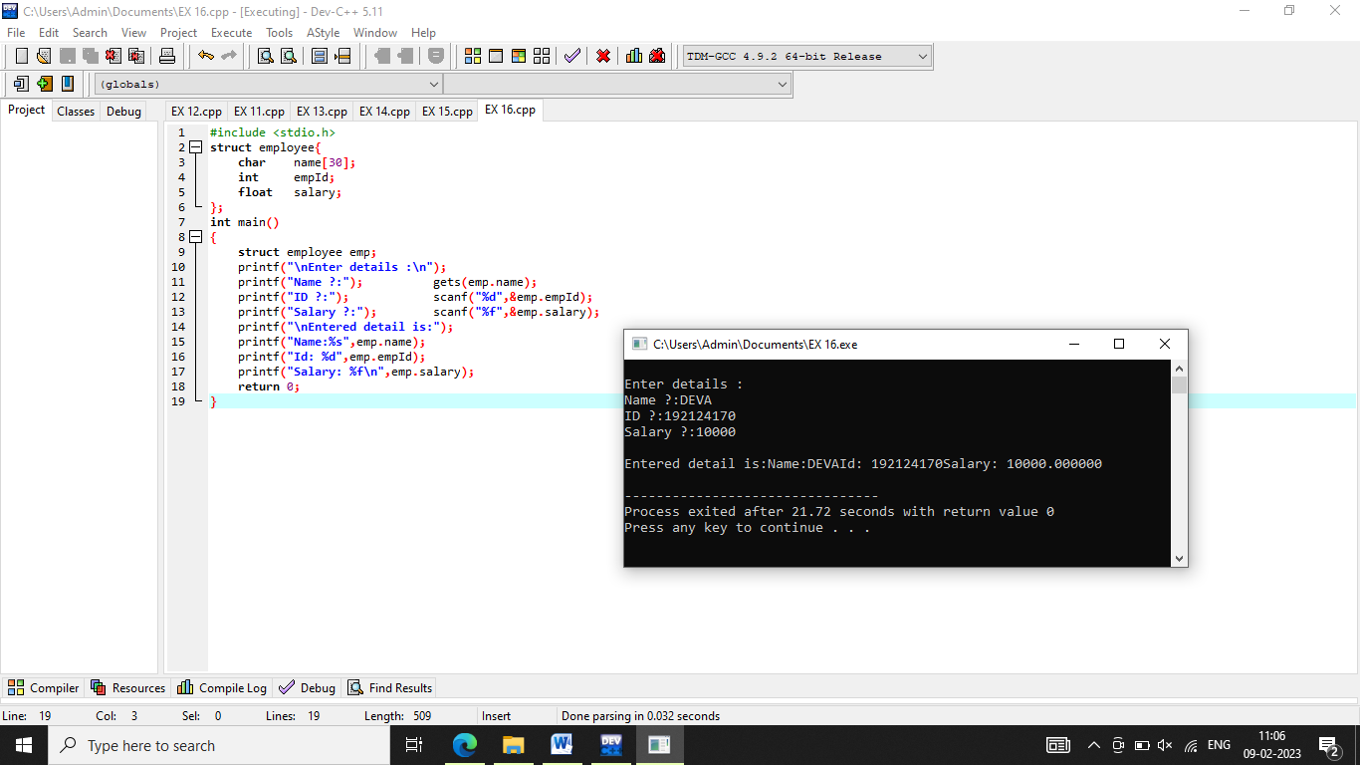

**17. Illustrate the deadlock avoidance concept by simulating Banker’s algorithm with C.**

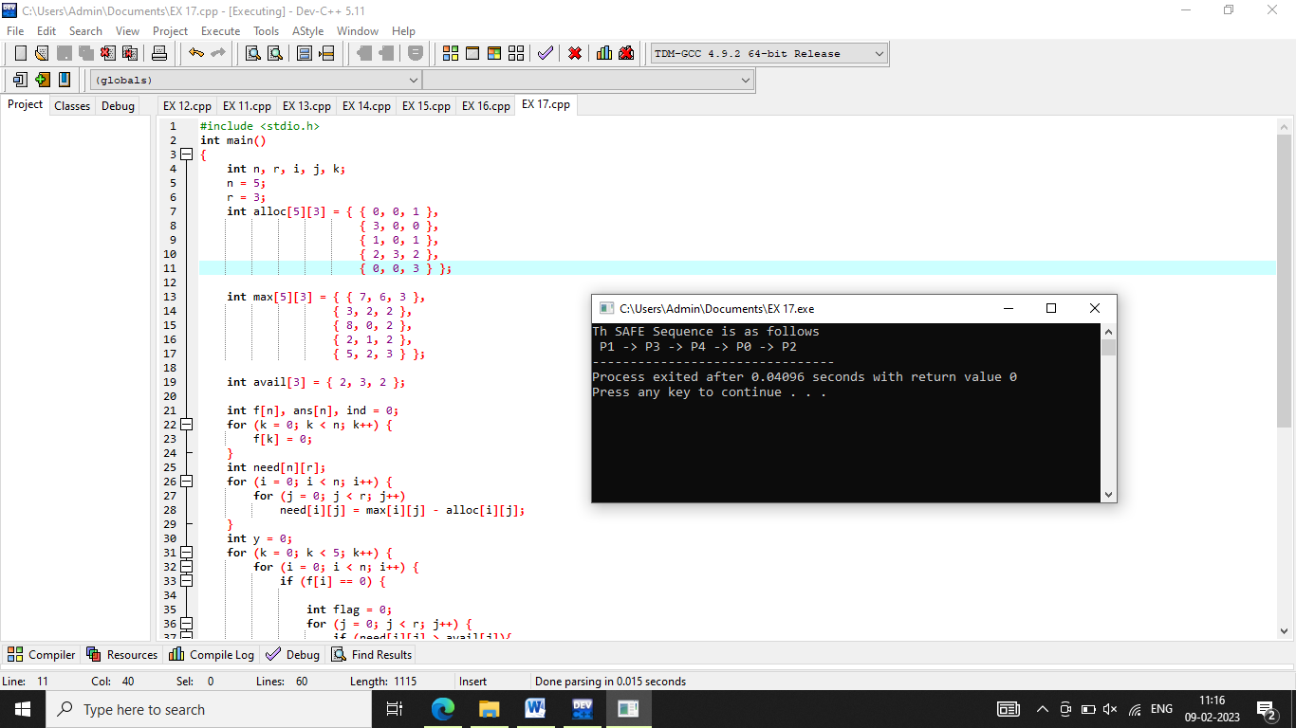

**18.Construct a C program to simulate producer-consumer problem using semaphores.**

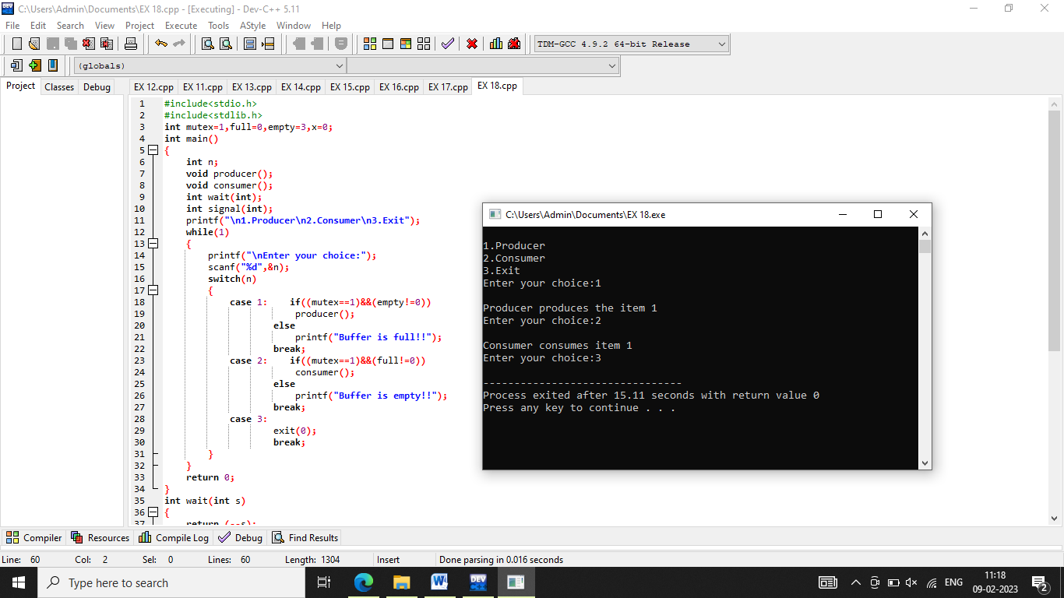

**19. Design a C program to implement process synchronization using mutex locks.**

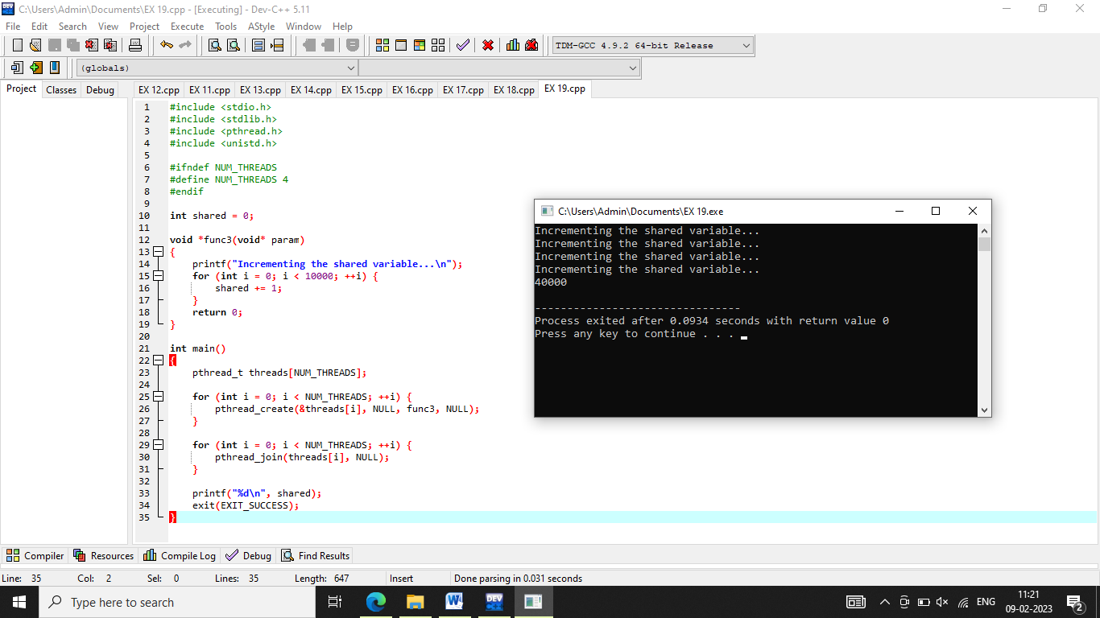

**20. Construct a C program to simulate Reader-Writer problem using Semaphores.**

